LAB EXPERIMENTS

DAA-CSA0619
TOPIC 3: DIVIDE AND CONQUER

- Find Maximum and Minimum Using Divide and Conquer

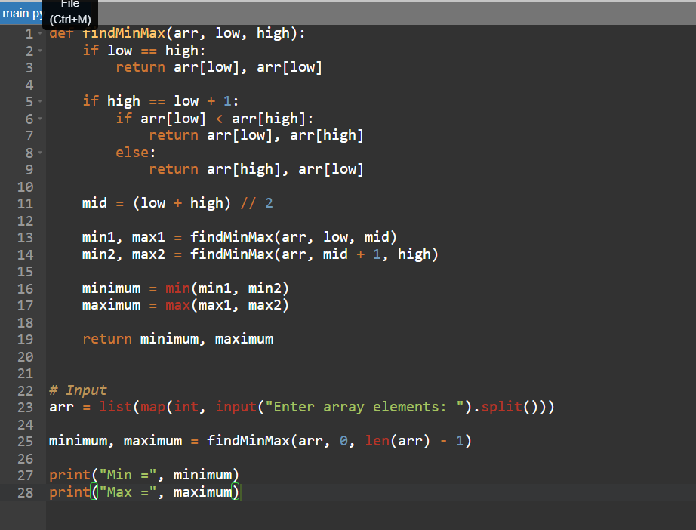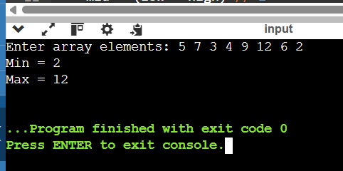
Time Complexity:
O(n)
Space Complexity:
O(log n) due to recursive calls.

2.Find Maximum and Minimum in a Sorted Array

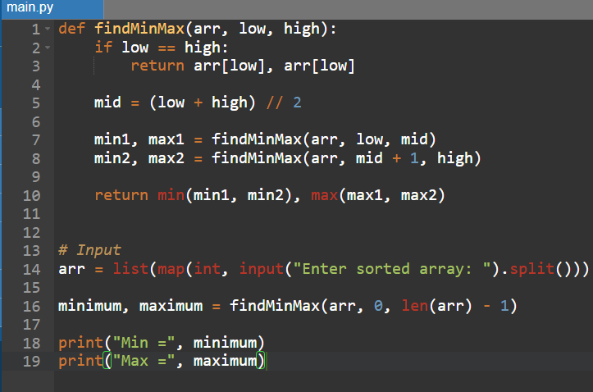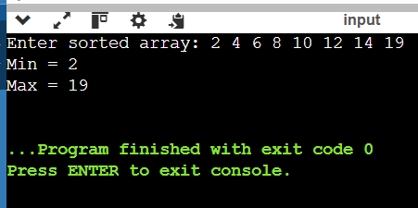

Time Complexity:
O(n)
Space Complexity:
O(log n)

3. Merge Sort
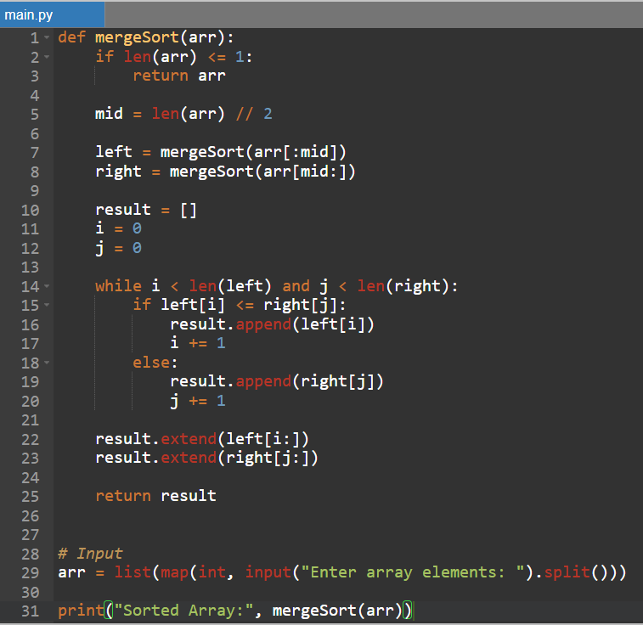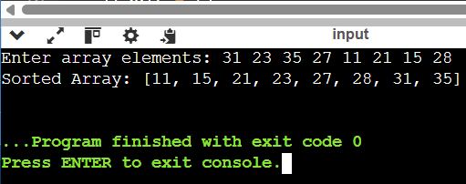
Time Complexity:
O(n log n)
Space Complexity:
O(n)

- Merge Sort with Comparison Count:

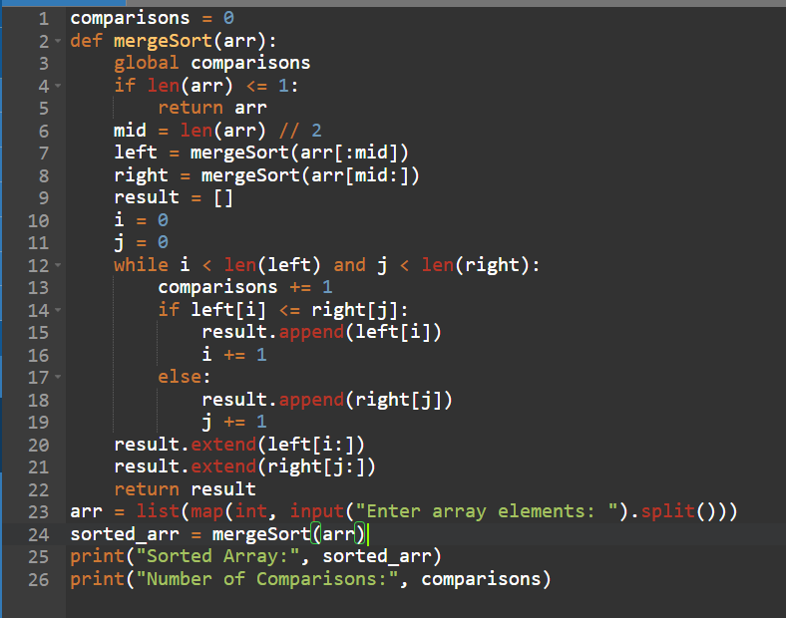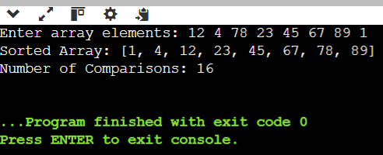
Time Complexity:
O(n log n)
Space Complexity:
O(n)

- Quick Sort – First Element as Pivot:

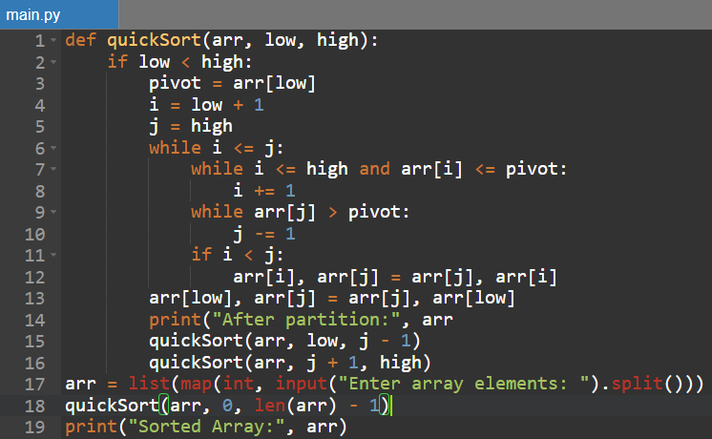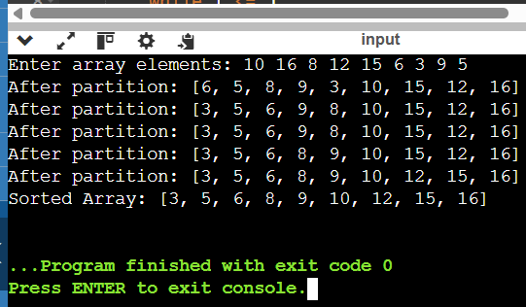
Time Complexity:
Best/Average: O(n log n)
Worst: O(n²)
Space Complexity:
O(log n) average due to recursion.

- Quick Sort – Middle Element as Pivot:

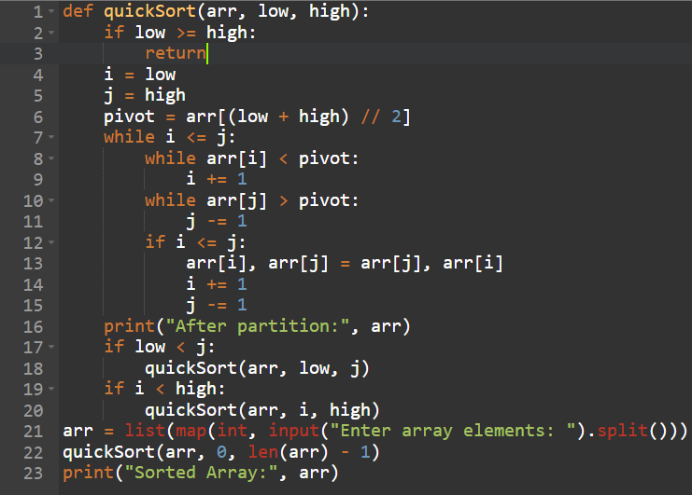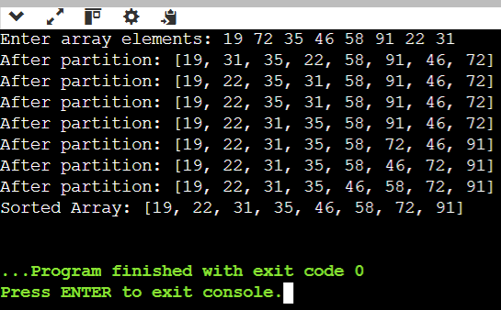
Time Complexity:
Best/Average: O(n log n)
Worst: O(n²)
Space Complexity:
O(log n) average due to recursion.

- Binary Search with Comparison Count:

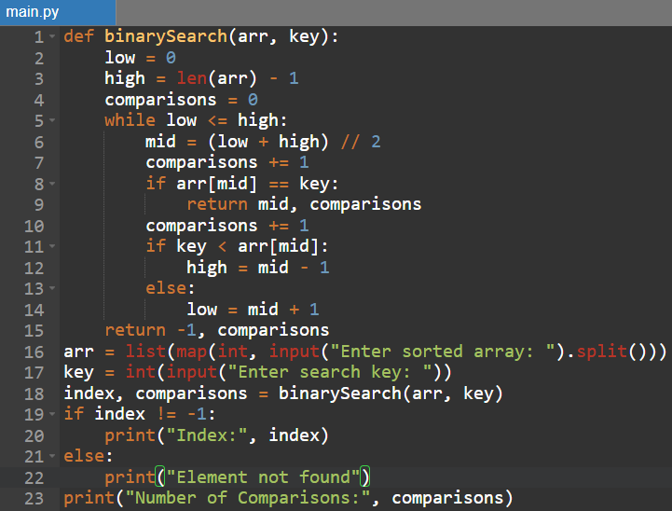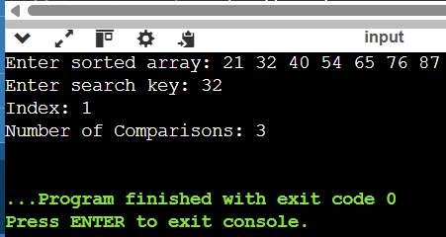

Time Complexity:
O(log n)
Binary Search eliminates half of the search space in every step.
Space Complexity:
O(1)

8. Binary Search with Mid-Point Steps:

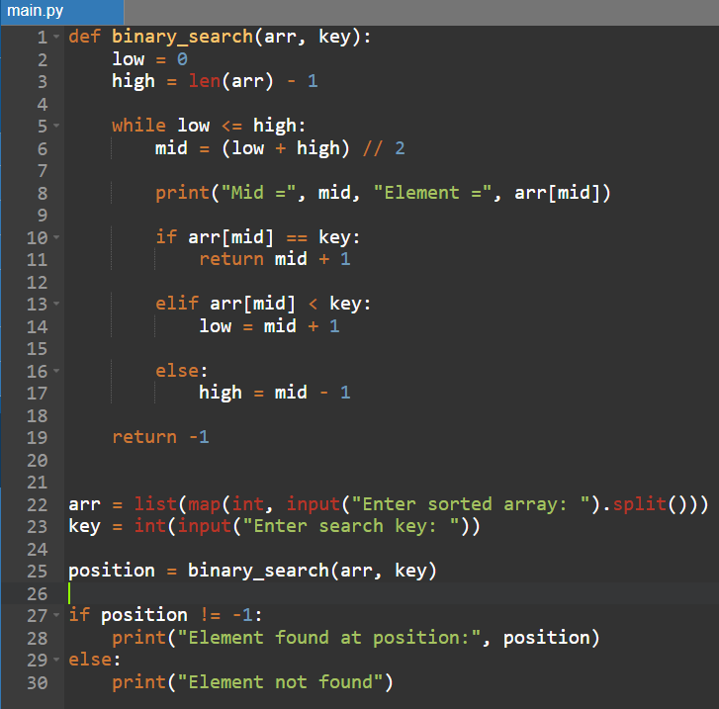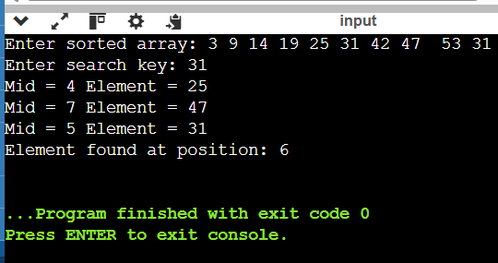
Time Complexity:
O(log n)
Space Complexity:
O(1)

9 . K Closest Points to Origin:

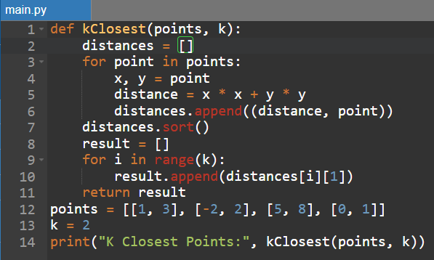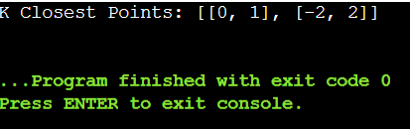
Time Complexity:
O(n log n)
Space Complexity:
O(1)

- Four Sum II:

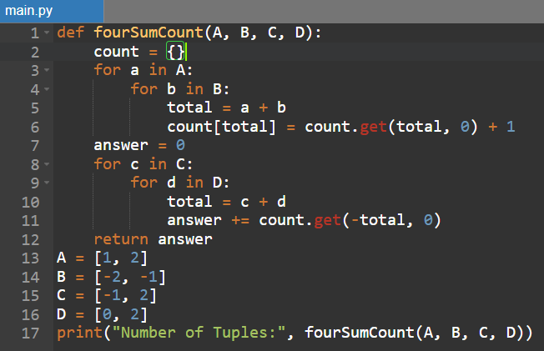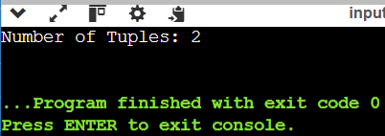
Time Complexity:
O(n²)
Space Complexity:
O(n²)

- Median of Medians :

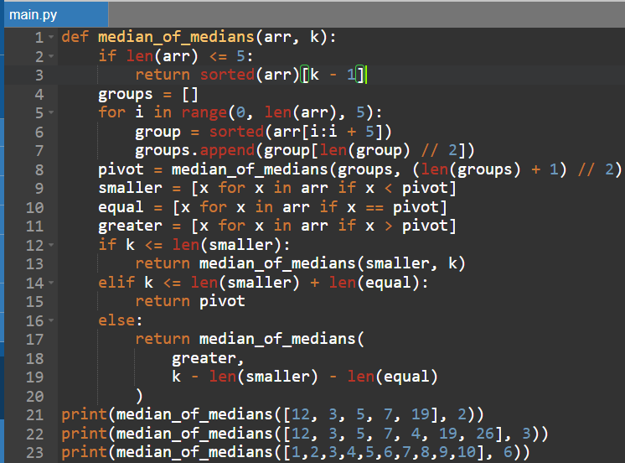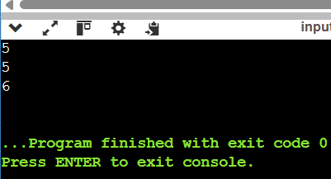
Time Complexity:
O(n) worst case.
Space Complexity:
O(n) for the auxiliary lists used.

- Median of Medians Function:

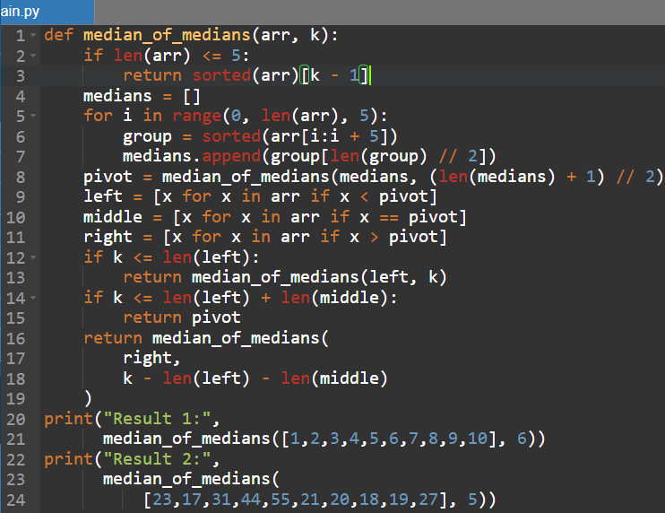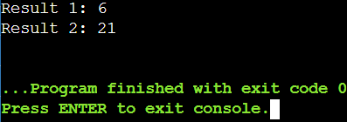
Time Complexity:
O(n) worst case.
Space Complexity:
O(n)

- Meet in the Middle – Closest Subset Sum:
Time Complexity:
O(2^(n/2)) approximately.
Space Complexity:
O(2^(n/2))
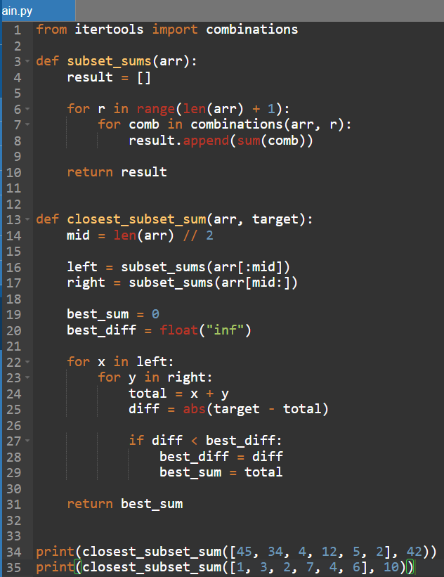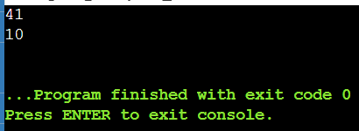

- Meet in the Middle – Exact Subset Sum:

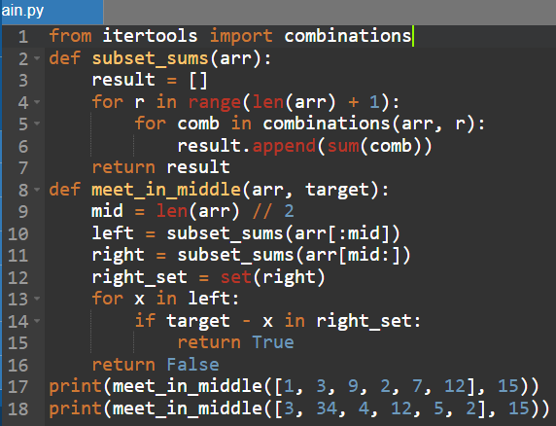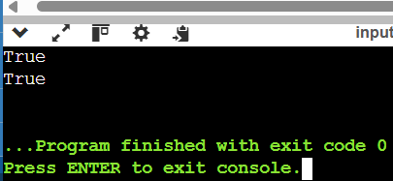
Time Complexity:
O(2^(n/2)) approximately.
Space Complexity:
O(2^(n/2))

- Strassen's Matrix Multiplication:

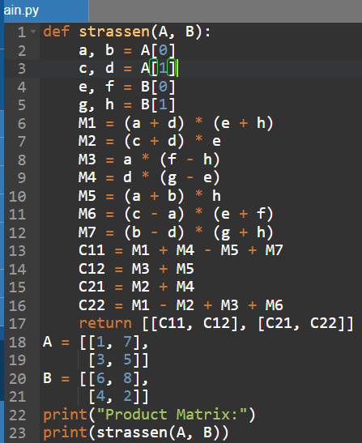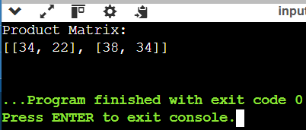
Time Complexity:
O(n^log₂7) ≈ O(n^2.807)
Space Complexity:
O(n²)

- Karatsuba Multiplication:

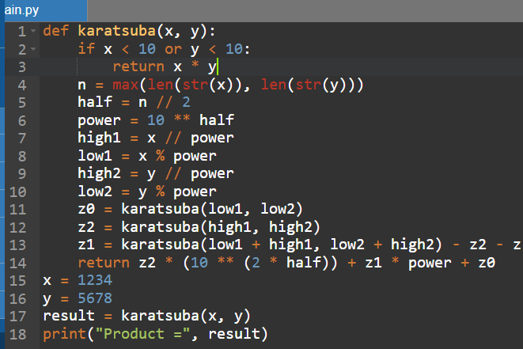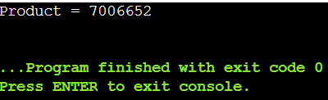

Time Complexity:
O(n^log₂3) ≈ O(n^1.585)
Space Complexity:
O(n) due to recursive calls.

3.

4.

5.

